Experiment worksheet

5.1 Using computer simulations

Pages 112–115 and 210

Challenge 5.1: Using computer simulations

Scientists can’t always find answers to big questions by doing experiments. Often the risks are too great or the experimental method is outside the limits of current technology. Answers to problems like this can sometimes be found using computer simulations.

A computer simulation takes an established pattern and extends it to make a prediction about further events. A simulation is a type of model and, just like other models, it isn’t always accurate, but it is the best possible inference or answer to a big question that cannot be tested in any other way. Computer simulations can also be used for experiments that require a lot of repetition that would take a scientist a long time to complete manually, or to infer data about places we can’t go to, like other planets or below the crust of our own planet.

Scientists know that the Earth’s mantle is 2800 km thick and that the temperature near the point where the crust and mantle meet is approximately 500°C. Your job is to find out the temperature of the mantle at its deepest point: 2800 km below the Earth’s surface.

1 Enter the information from the following table into a spreadsheet program, such as Microsoft Excel or similar.

|  |  |
| --- | --- |
| Depth under mantle (km) | Temperature (°C) |
| 100 | 500 |
| 200 | 598 |
| 300 | 696 |
| 400 | 794 |
| 500 | 892 |
| 600 | 990 |

2 Create a scatter graph of this information using the graphing function of the computer program. Make sure that temperature is on the y-axis and depth is on the x-axis.

3 Extend the data in the table until you reach a ‘Depth under mantle’ of 2800 km. Do this by using the ‘fill handle’ tool (select the cells in the Excel worksheet and click and drag the small square that appears in the lower right corner of the selection).

4 Update your graph to represent this new data.

• Does the temperature at a depth of 2800 km match the information you have read above? Explain why there is a variance.

• The process you have just followed only works for ‘linear’ data, which is data that increases or decreases at a constant level. Suggest another experiment you have conducted this year that you could have completed by this process.

• Similar modelling is conducted using data about weather and climate. What predictions would scientists want to make with regard to weather and climate? Why would these predictions be useful?

More complex computer simulations are also available to process much more complicated, or non-linear, data.

Experiment worksheet

5.2 Matter cycles through the Earth’s spheres

Pages 116–119 and 211

Experiment 5.2: Testing phosphorus

Aim

To determine if phosphorus is present in a variety of detergents.

Materials

• Variety of detergents

• Phosphorus testing kit

• Test tubes and test-tube rack

• Measuring cylinder

Method

1 Add 9 mL of distilled water to a test tube.

2 Add 1 mL of detergent to the test tube.

3 Follow the instructions of the phosphorus testing kit to determine if there is phosphorus present in the detergent.

4 Repeat steps 1–3 with the remaining detergents.

Results

Record your observations in an appropriate table.

|  |
| --- |
|  |

Discussion

1 What detergents contained phosphorus?

|  |
| --- |
|  |
|  |

2 Why do living organisms need phosphorus?

|  |
| --- |
|  |
|  |
|  |
|  |

3 Why are high levels of phosphorus in waterways a problem?

|  |
| --- |
|  |
|  |
|  |
|  |

4 Check the labels on the detergents in your home. What phosphorus-containing detergents do you use regularly?

Conclusion

What do you know about the phosphorus cycle?

|  |
| --- |
|  |
|  |
|  |
|  |
|  |

Experiment worksheet

5.3 The water cycle is a global cycle

Pages 120–123 and 211

Experiment 5.3: Make your own clouds

Aim

To simulate the process of condensation.

Materials

• Ice cubes

• Water

• Bench mat

• Tripod

• 250 mL beaker

• Gauze mat

• Evaporating dish

• Matches

• Bunsen burner

• Safety glasses

Method

1 Set up the apparatus as shown in Figure 1.

2 Heat the water in the beaker until it boils.

3 Turn the gas off and place an ice-filled evaporating dish on top of the beaker.

4 Carefully observe what happens.

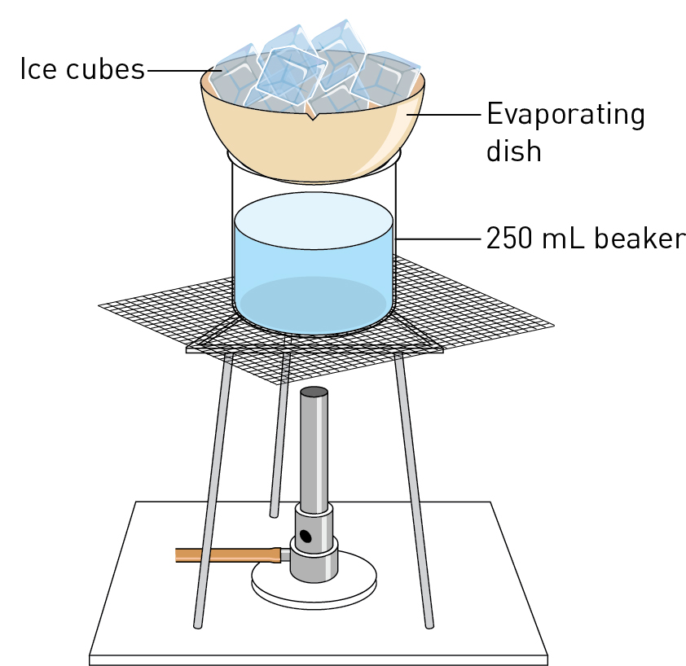**Figure 1** Experimental set-up.

Results

Include your observations in an appropriate format.

|  |
| --- |
|  |

Discussion

1 What action produced water vapour?

|  |
| --- |
|  |

2 What happened to the water vapour?

|  |
| --- |
|  |

3 In which of the Earth’s spheres would you find water vapour?

|  |
| --- |
|  |

4 Why is the condensation of water important to the biosphere?

|  |
| --- |
|  |
|  |

Conclusion

What do you know about the importance of water condensation in the Earth’s spheres?

|  |
| --- |
|  |
|  |
|  |
|  |

Experiment worksheet

5.3 The water cycle is a global cycle

Pages 120–123 and 212

Challenge 5.3: Making a simple barometer

What you need

• Glass jar

• Rubber balloon

• Rubber band

• Straw

• Sticky tape

• Sheet of thick paper with a scale marked on it

What to do

1 Cut a section from the balloon large enough to cover the opening of the jar.

2 Secure the balloon rubber over the jar with the rubber band.

3 Tape the straw onto the balloon.

4 Place the paper with the scale near the end of the straw and mark on the scale where the straw is.

5 Check the position of the straw on the scale over a few days. Mark each position of the straw (Figure 1).

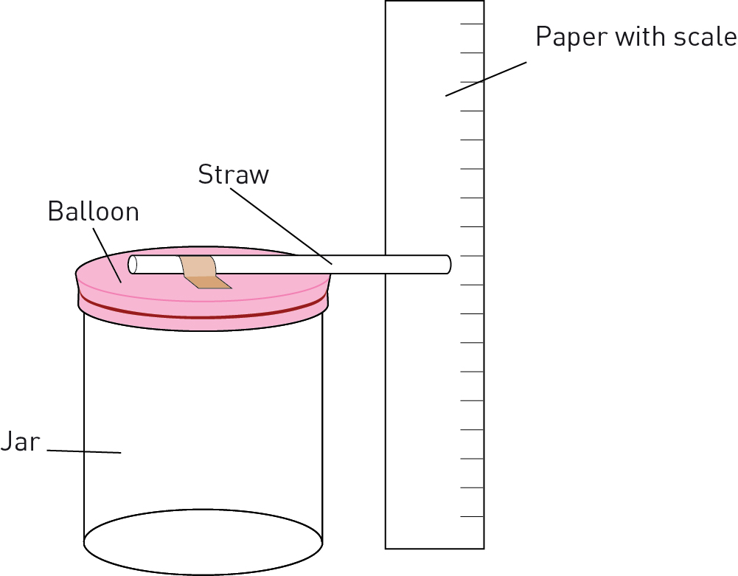

Figure 1 Experimental set-up.

Discussion

1 What happened to the rubber balloon as the outside air pressure changed?

|  |
| --- |
|  |
|  |
|  |

2 What happened to the position of the straw against the scale? Why was this?

|  |
| --- |
|  |
|  |
|  |

3 Use the particle model of air to explain why the rubber balloon gets pushed in or out of the jar by the surrounding air.

|  |
| --- |
|  |
|  |
|  |

4 This ‘barometer’ will also respond to changes in temperature in addition to changes in air pressure. Explain why.

|  |
| --- |
|  |
|  |
|  |
|  |
|  |

Experiment worksheet

5.4 Human activity affects the carbon cycle

Pages 121–123 and 212

Challenge 5.4: Modelling a carbon sink

This activity may be demonstrated by your teacher.

What you need

• Dry ice

• 100 mL water

• Universal indicator

• 200 mL beaker

• Piece of netting

• Watch glass that covers the top of the beaker

• Sticky tape



CAUTION: Dry ice is frozen carbon dioxide (–79°C). Do not touch the dry ice with your fingers or metal objects. Use wooden or plastic tongs. Do not seal dry ice in any container as the gas expands rapidly.

What to do

1 Place the water in the beaker.

2 Add 5 drops of universal indicator to the water.

3 Place the netting over the top of the beaker and push down the centre slightly. This will provide a pouch to suspend the dry ice above the water. Use sticky tape to hold the netting in place.

4 Place a piece of dry ice in the netting and place the watch glass over the top of the beaker.

5 Observe any colour changes in the water.

Discussion

1 What happened to the solid dry ice?

|  |
| --- |
|  |
|  |
|  |

2 Describe any changes you noticed in the water.

|  |
| --- |
|  |
|  |
|  |

3 What was the final pH of the water?

|  |
| --- |
|  |

4 Provide an explanation for the changes you noticed.

|  |
| --- |
|  |
|  |
|  |

5 What is a carbon sink?

|  |
| --- |
|  |
|  |
|  |

6 How could you use this demonstration to explain the consequences of increased carbon dioxide levels in the atmosphere?

|  |
| --- |
|  |
|  |
|  |

Experiment worksheet

5.5 Evidence supports enhanced global warming

Pages 126–129 and 213

Experiment 5.5A: What factors affect a greenhouse?

Aim

To determine which surfaces of the Earth absorb energy and radiate it as heat and so are likely to contribute most to the warming of the atmosphere.

Materials

• 3 cups of dark soil

• 3 cups of white sand or perlite

• White paint

• Water

• 6 identical clear, empty 600 mL soft-drink bottles with labels removed

• 6 one-hole rubber stoppers with thermometers inserted that fit securely into the bottle top or data-logging equipment using long steel temperature probes with Blu Tack to secure the probe in place

• 6 plastic containers at least 11.5 cm in diameter at the top (e.g. margarine containers)

• Funnel

• Sunlight or one 150 W floodlight bulb

• Portable reflector lamp

• Stand to support the lamp set-up (retort stand and clamps)

Method

1 Work as a group and label the bottles A, B, C, D, E and F. Paint the upper one-third of bottles B, D and F white to represent cloud cover.

2 Use a funnel to fill the base of bottles A and B with dark soil, bottles C and D with white sand or perlite, and bottles E and F with room-temperature water. Ensure that you use the same depth (5–7 cm) in each bottle.

3 Put the thermometers inserted in the rubber stoppers into the bottle tops. Ensure that the bulbs are just above the top of the dirt, water, perlite/sand. If the bulbs are below the base, they may record the heat absorbed directly by the soil or water, which will affect your data. You want to measure the temperature of the air (atmospheric). If using a data-logger temperature probe, secure and seal into the top of the bottle with Blu Tack.

4 Record the initial baseline atmospheric temperature of each bottle in a table.

5 If it is a sunny day, take your bottles outside and record the temperatures of each bottle in a table every 2 minutes for at least 20 minutes. Alternatively, set up the 150 W light source on a stand facing down. Place the bottles underneath the light source approximately 15 cm away from the lamp. It is important that all bottles receive equal light. Depending on your light source, you may be only able to do two bottles at a time. If this is the case, ensure the two bottles have the same base; for example, dirt.

Results

Predict which bottle will get hottest and justify your prediction. Draw a graph of time (in minutes) versus temperature to record your observations.

Discussion

1 Compare the graphs for the different bottles. Describe the differences. What do these graphs indicate?

|  |
| --- |
|  |
|  |

2 Which situation produced the lowest temperature? Which situation would lead to the least heating of the atmosphere?

|  |
| --- |
|  |
|  |

3 Suggest some possible explanations for your results.

|  |
| --- |
|  |
|  |

4 Explain how this experiment demonstrates the effect of the oceans and dark and light surfaces on air temperature.

|  |
| --- |
|  |
|  |

5 If the deserts are increasing and ice is melting, exposing dark soil, what effects would you expect these changes to have on atmospheric temperature?

Conclusion

Summarise your key findings from this experiment.

|  |
| --- |
|  |
|  |
|  |
|  |
|  |

Experiment worksheet

5.5 Evidence supports enhanced global warming

Pages 126–129 and 214

Experiment 5.5B: Melting ice and its effect on sea levels

Aim

To observe the effect of melting sea and sheet ice on global sea levels.

PART A: SEA ICE

Sea ice is floating ice, like the ice found in icebergs. Design an experiment that shows the effects of melting sea ice on water level (e.g. an ice cube floating on water).

PART B: SHEET ICE

Sheet ice is ice resting on land. Approximately 98% of Antarctica is covered by sheet ice and the Antarctic ice sheet is one of two polar ice sheets. Design an experiment that shows the effects of a melting ice sheet on water level (e.g. an ice cube resting on clay).

Results

Present your results for each experiment in an appropriate format.

Discussion

1 How did the water level change as the sea ice melted?

|  |
| --- |
|  |
|  |

2 How did the water level change as the sheet ice melted?

|  |
| --- |
|  |

3 Provide an explanation for any differences you observed.

|  |
| --- |
|  |

Conclusion

Will melting sea ice or melting sheet ice have the greater effect on sea levels? Why?

|  |
| --- |
|  |
|  |
|  |
|  |
|  |

Experiment worksheet

5.6 Enhanced global warming has widespread effects

Pages 126–129 and 214

Challenge 5.6: Salt water density

What you need

• Salt

• Water

• Measuring spoons

• Food colouring (4 different colours)

• Test tube and test-tube rack

• 4 × 200 mL beakers

• Pipette

What to do

1 Add 150 mL of water to each beaker. Label the beakers 1–4.

2 Add 1 teaspoon of salt to beaker 2 and mix thoroughly.

3 Add 2 teaspoons of salt to beaker 3 and mix thoroughly.

4 Add 3 teaspoons of salt to beaker 4 and mix thoroughly.

5 Add a different food colour to each beaker of salt and water.

6 Use the pipette to add 2 cm of salty water from beaker 4 to the bottom of the test tube.

7 Carefully use the pipette to add 2 cm of the salty water from beaker 3 so that it runs down the sides of the test tube. Be careful not to mix the two solutions.

8 Repeat the previous step with beaker 2 and then beaker 1 so that you achieve a test tube with different coloured layers.

Discussion

1 What is density?

|  |
| --- |
|  |
|  |

2 Which is denser, beaker 1 or beaker 4? Provide evidence from your results to support your answer.

|  |
| --- |
|  |
|  |
|  |

3 Relate your results to the movement of water in ocean currents.

|  |
| --- |
|  |
|  |
|  |
|  |